



**Al Imam Mohammad ibn Saud Islamic University**

**College of Computer and Information Sciences**

**Information Systems Department**

**Booking website**

|  |  |  |
| --- | --- | --- |
| **ID** | **NAME** | **Section #** |
|  |  | *371* |
|  |  | *371* |

Project Submitted in Fulfillment for the [IS203] Course requirements

Fall 2016

**Table of Contents**

|  |  |
| --- | --- |
| Introduction | 3 |
| Project Chapters | 4 |
| Conclusions | 12 |
| Coding | 13 |

**Introduction**

We are here today, to present our booking web projects.

We have created this web application to help people finding good spots and places to visit, and leave a message and book a trip.

We made sure that we present our projects in a very pretty way, so the visitor feels like if he wants to visit one of these places as soon as possible.

**Project Chapters**

* A welcome page including an audio sound and a GIF welcome image as a background.

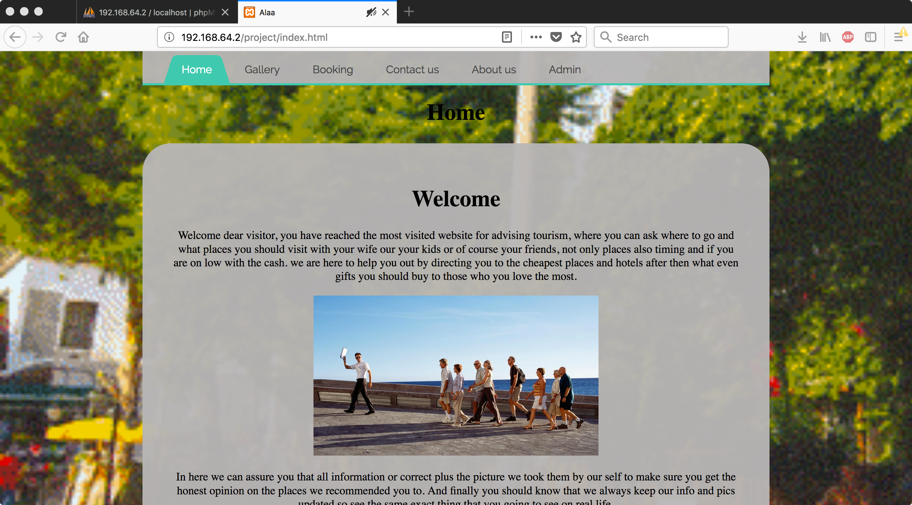

We had to use a dynamic tag that would play us the audio file automatically, and we hided the controllers to make it look nice.

We download very fast video of guy recording his town then we converted that video into GIF file after that we made it our background using CSS.

* About us with a short cv of the developer(s) details (photo, name, interests, degrees) on the one side and a relevant background image on the other side.

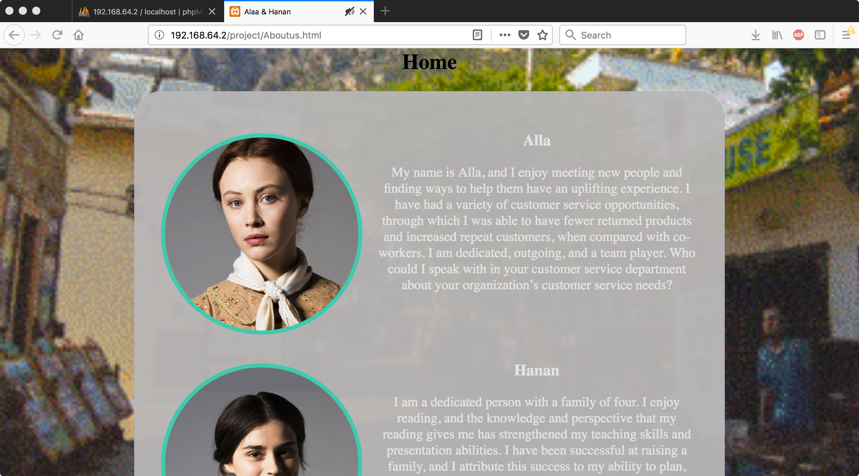

We have typed a small amount of information about us as requested, we also add an image for each one of us, **using CSS** (border-radius) we made our profile picture in cereals to make it look nicer.

* A contact page where you must present to the user your contact details with your logo as a background image **(10 points)** giving a chance for complaints and general communication. At the end of your working area and as a last line right before copyright line provide more than one choices of communication to the user. **(10 points)**

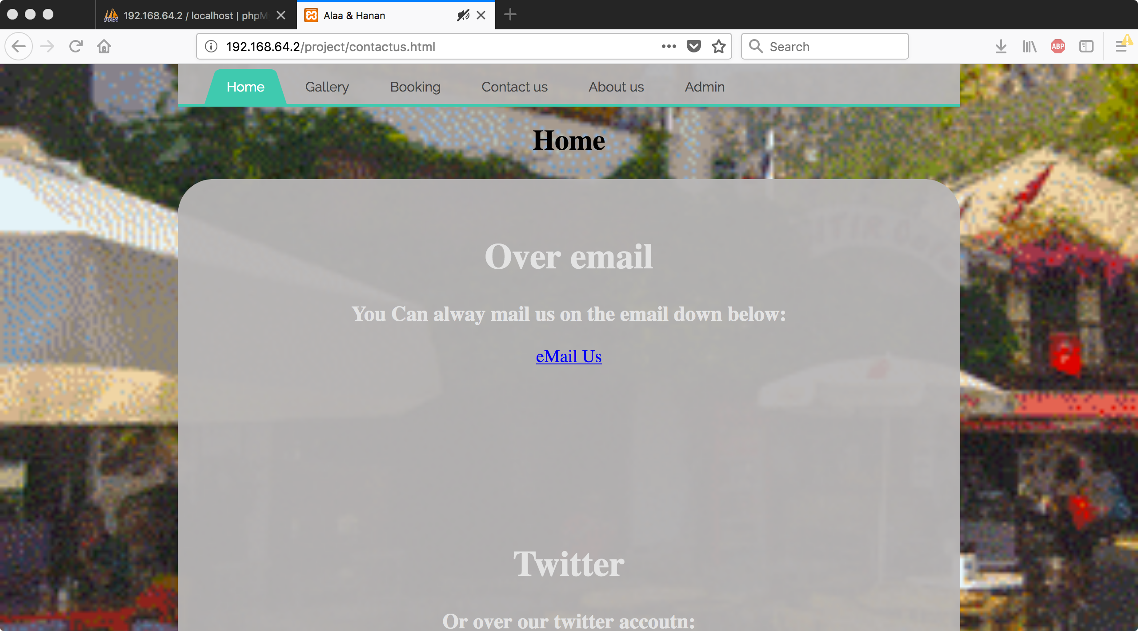

In this page we provided the visitor with our contact email, and twitter.  
We also have presented a form to leave us a complaint.

A page to display countries with their best construction projects and relevant information. Choose at least 5 countries to promote their best construction plans and make an image based menu with their flags (**5 points**). The exact type of information required and the specifications of the way to be viewed by the user follows:

i. When the user clicks a country from the image based menu, a background image of the map of the globe must be displayed and that country highlighted. (download those images from Wikipedia) (**5 points**)

ii. When the user wants to hover on the county’s flag then the name of this country must be displayed temporarily with a design of big and Italic fonts and if the user clicks on this flag logo image:

* 1. then 3-4 images or videos of the best ongoing or finished constructions is expected to be displayed in the whole working area (**5 points**)
* 2. with a basic information on this construction as a text presentation (**5 points**)

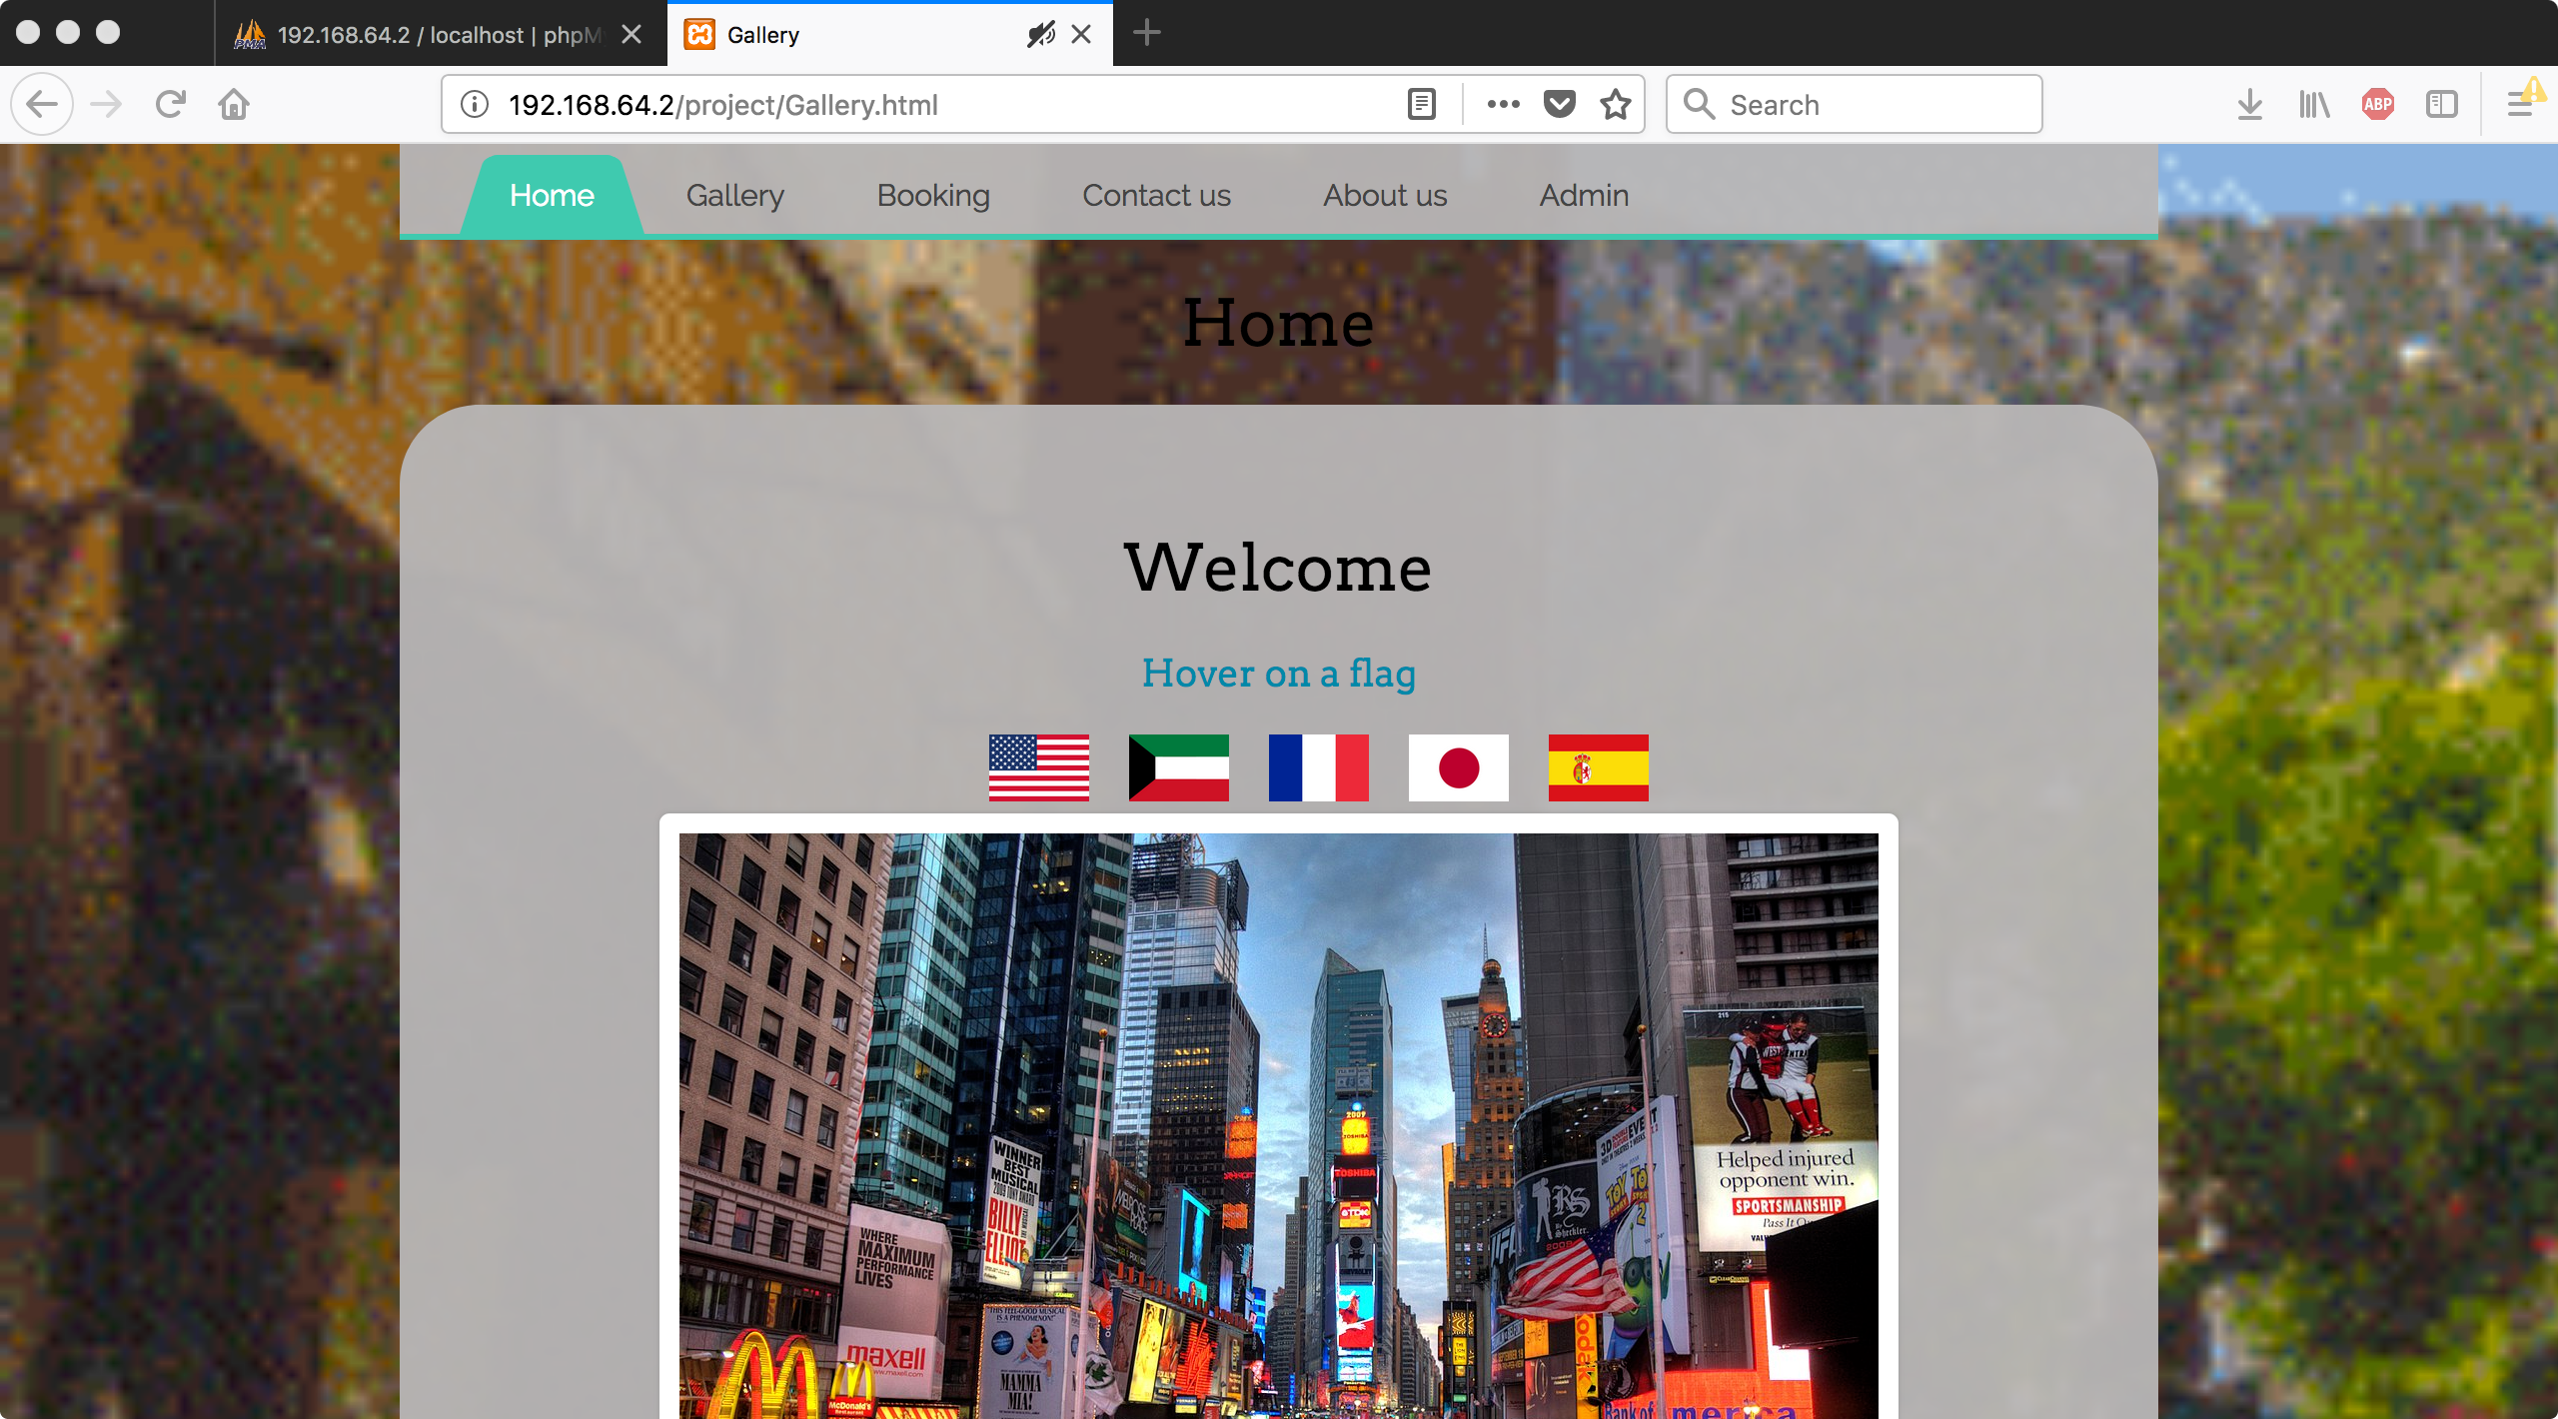

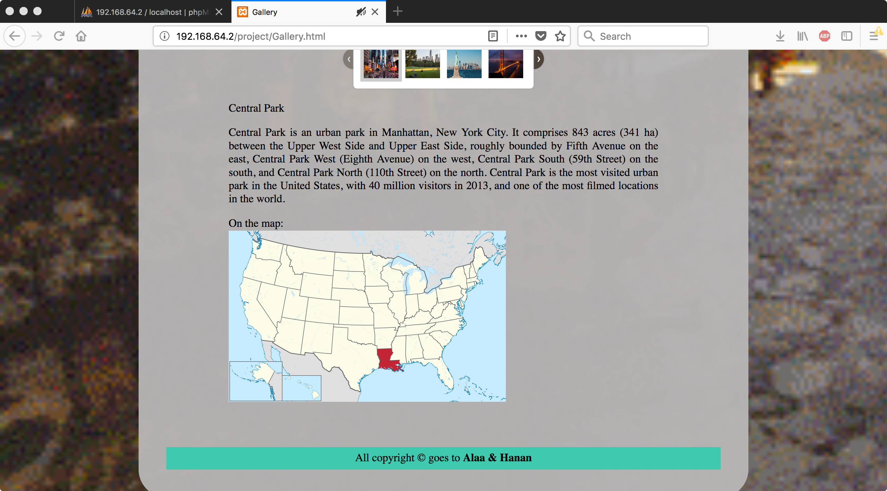

This was the more difficult page we been throe, working with JavaScript wasn’t easy as we thoughts.

We had to create folders and put each country in a different folder so we can fetch it with it in JavaScript.

We want to have more than 3 or 4 places to show our visitors, so we decided to promote **Five** places and we used a slider to make sure that we display our places in the best way there is.

After you click on one of these place you are going to get a small paragraph down below the slider which will be about the place that you have picked.

Before that:

Whenever the user hovers on a flag the name of that country must show up, we needed to use (onMouseOver) and (onMouseOut) and inside these two we had our JS function that will print and delete the country name from the top.

Lastly:

The chosen country must have a map and it must be displayed down in the very bottom of the page

* A web page - with a nice and controlled input design - prompting from the user personal data (First name, Last name, Mobile, Email address, Age and Profession) to store them inside an SQL database whenever the user clicks on the “register” button. A “clear” button for the data is required too. Perform at least 10 inputs and extract the data file on your folder files. (**10 points**)

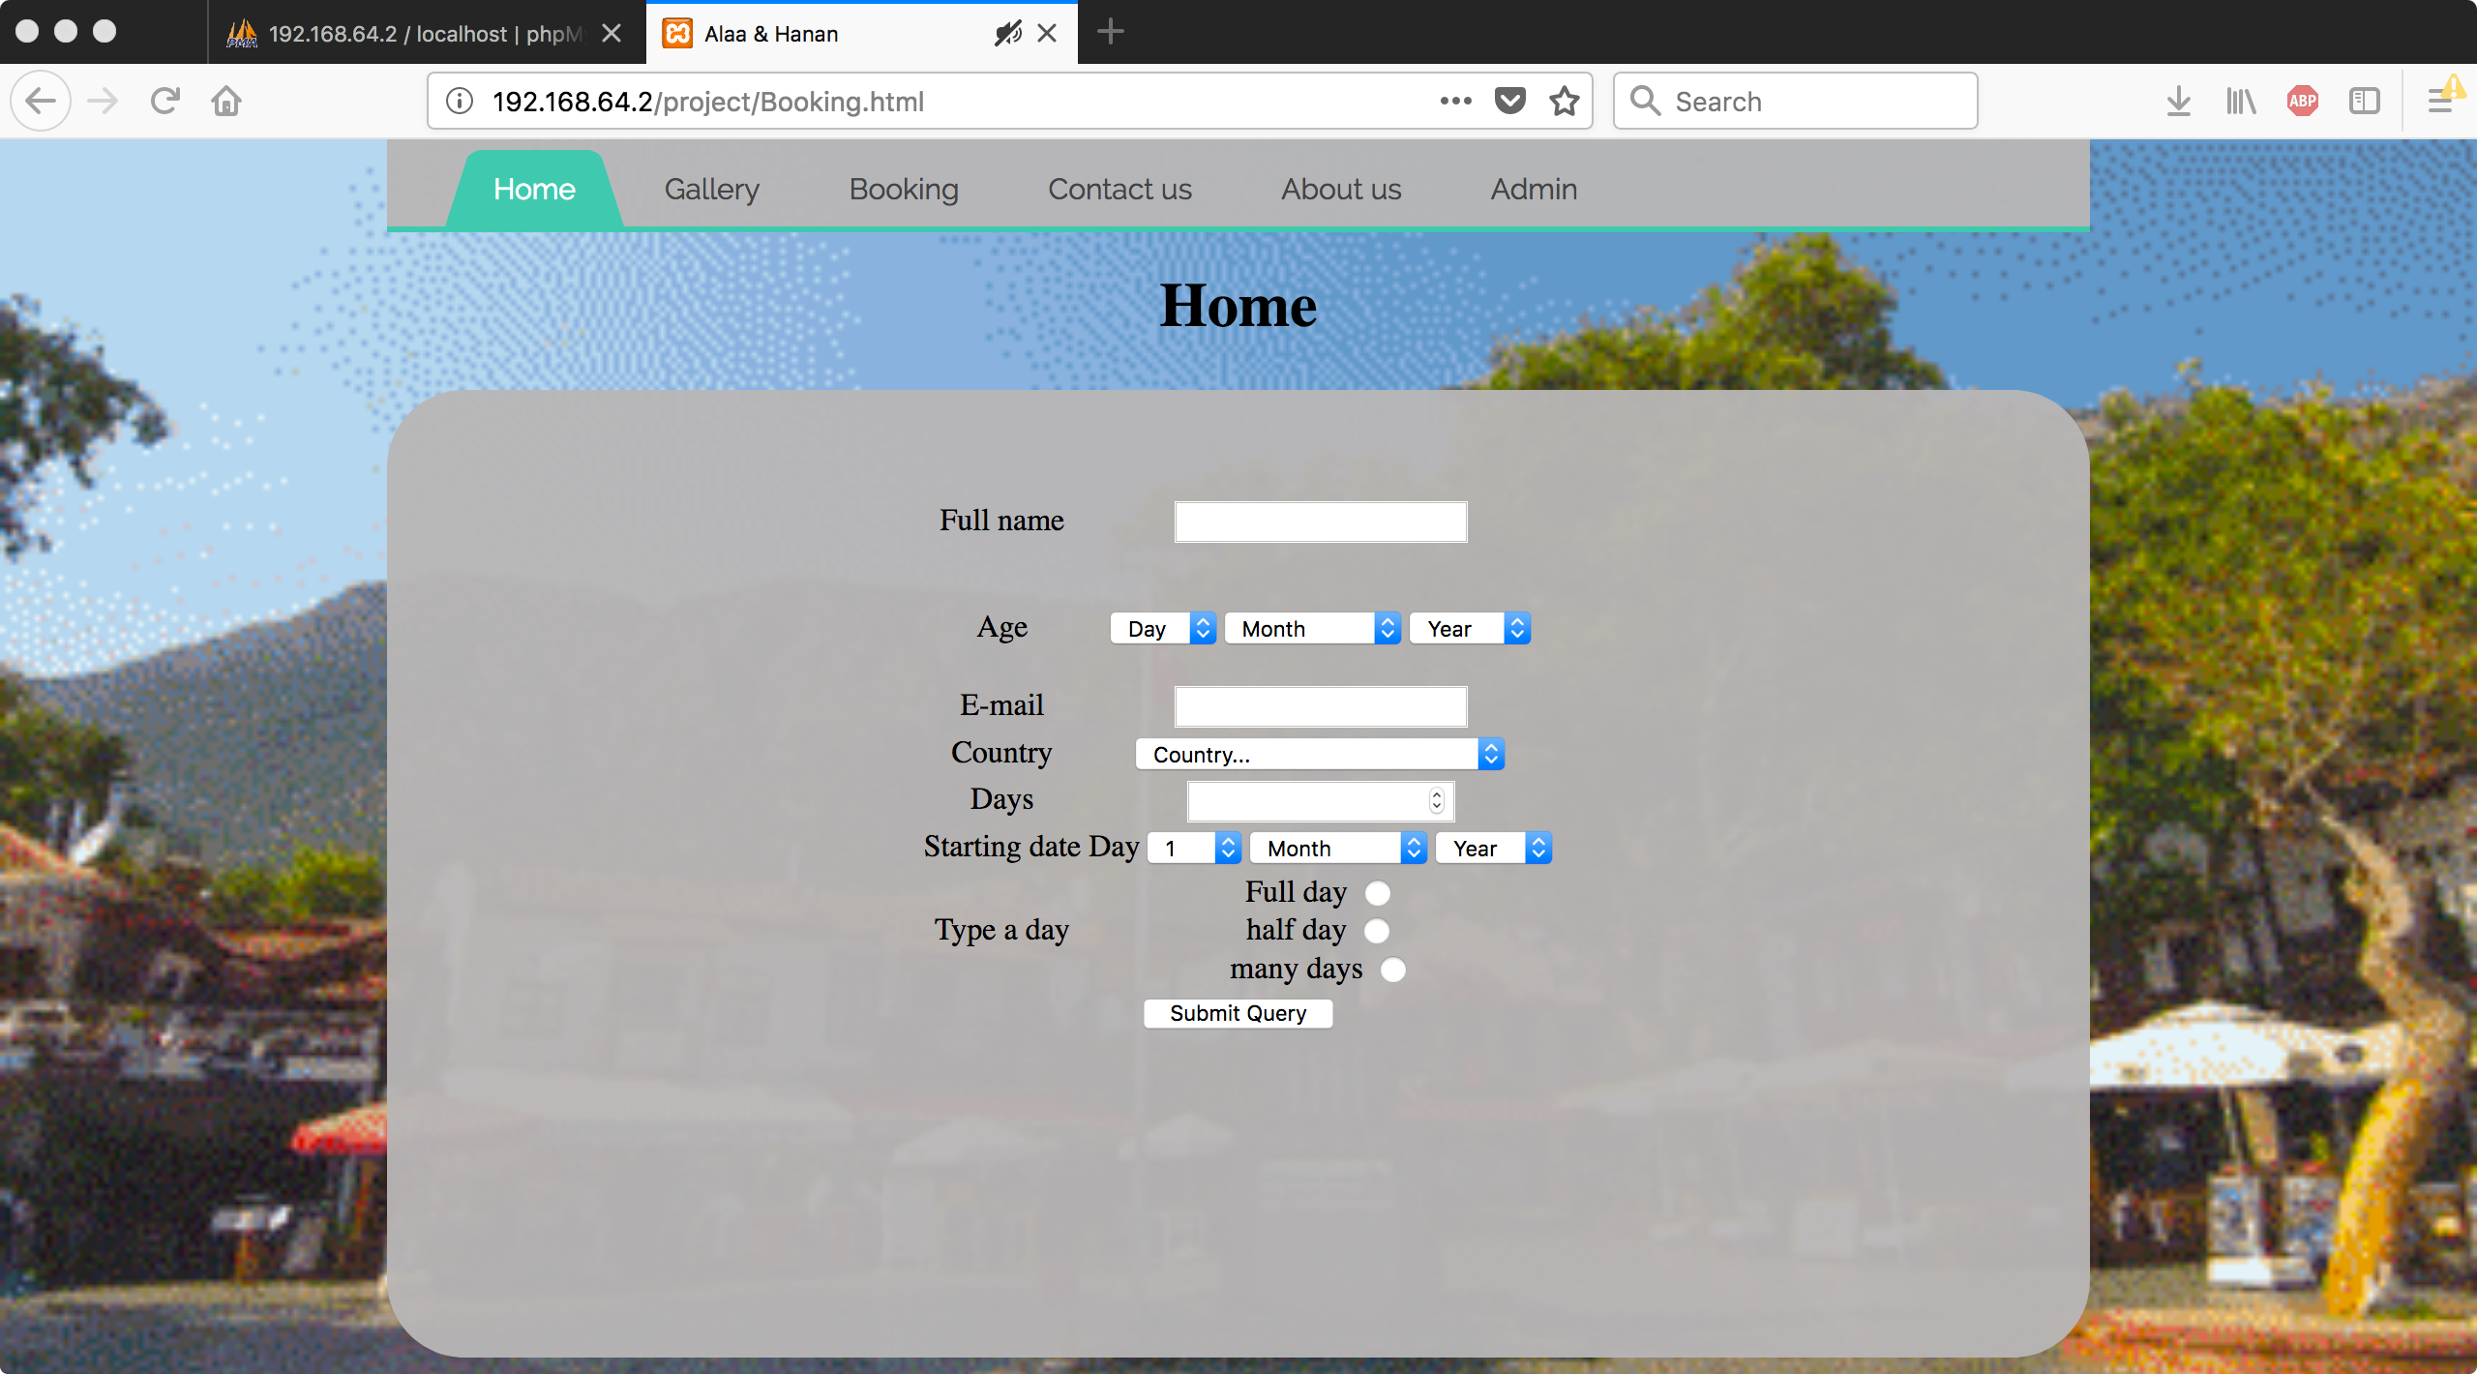

After we created our form the content twelve inputs field

* Name
* Phone number
* Guider
* Age
* Email
* Country
* Days
* Starting date
* Type of trip

To be creative, we billed our own input of date (drop down menu), instead of the regular way

However:

We straggled a little bit throw it in the begging because we need to put the (Day – Month - Year) along together to insert them then the insert command so in order to figure out where was the issue, we used (PHP MY ADMIN) to test our line, and we found that we were missing some of the commas.

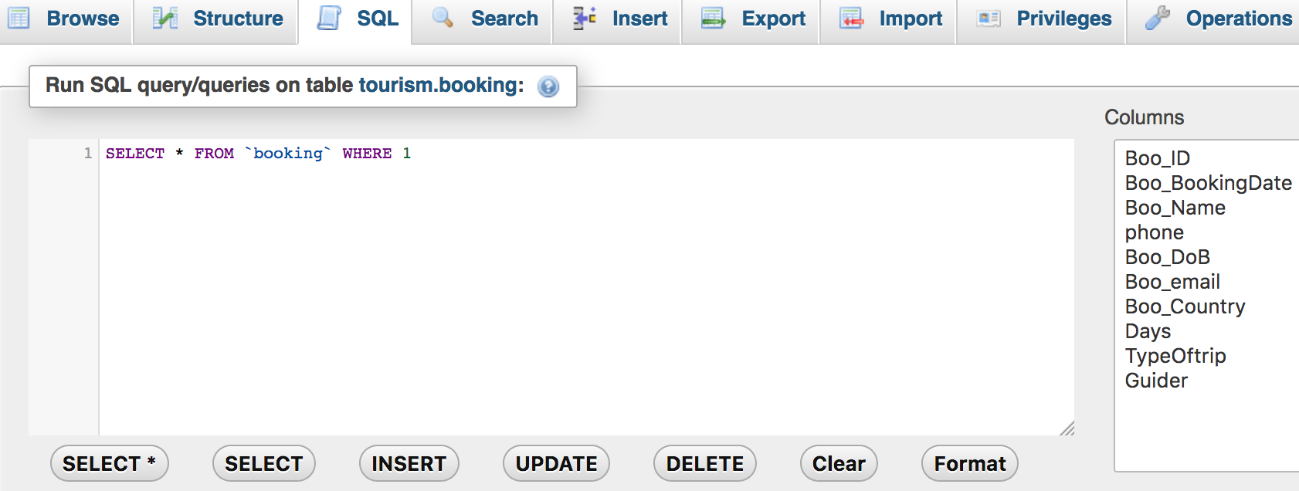

* A web page illustrating statistical results and interpretations on the previous list: i. Display a list of your database in a table manner with a nice design. (**5 points**)

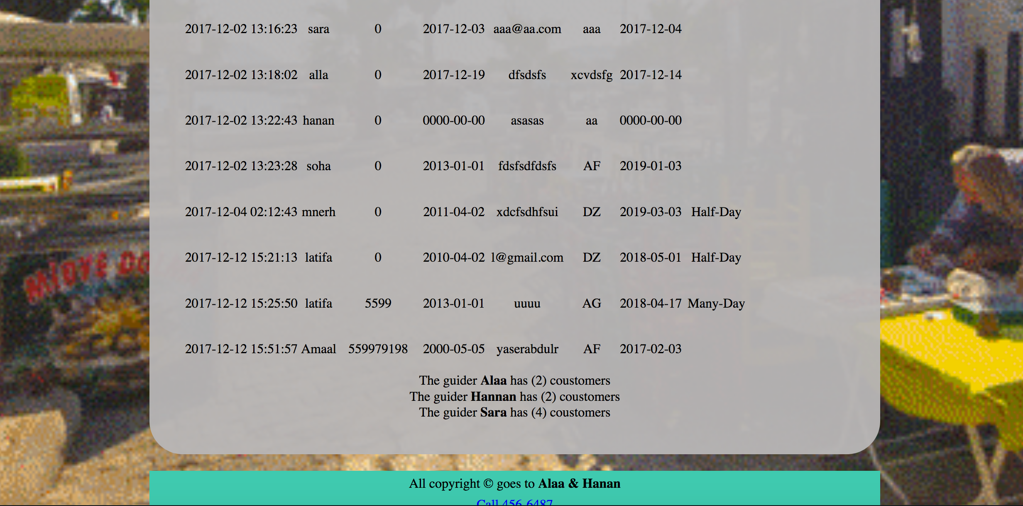

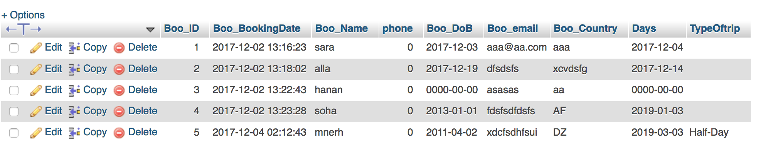

As requested, we directly retrieved the data using PHP then we had to print them,  
and for that we needed to use the php print command (Echo) and inside that echo we printed the HTML table plus the data we got from the database via PHP

In the bottom we have:

Each **Guider** and the how many customers she have.

To get that we had to make a query with a function (COUNT) plus (Group by)

[SELECT COUNT(Boo_ID),Guider FROM booking GROUP BY Guider]

**Conclusions**

We have learned a lot droning this projects, and I also used my skills that I had from my OGT (*on job thinning*).

Aiming one day to publish this site with real functions.

**Conclusion 1:**

In MySQL there a . $row["COUNT(Boo_ID)"].to make the id fill it self so we don’t have to check the id if it is duplicated or anything, it can do that by itself.

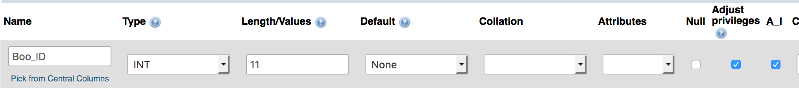

**Conclusion 2:**

we can also print JavaScript lines not only HTML using PHP:

**echo '**

**<script>**

**window.alert("'. $row["COUNT(Boo_ID)"].'");**

**</script>';**

And not only JavaScript anything as long it is going to be on the Clint side

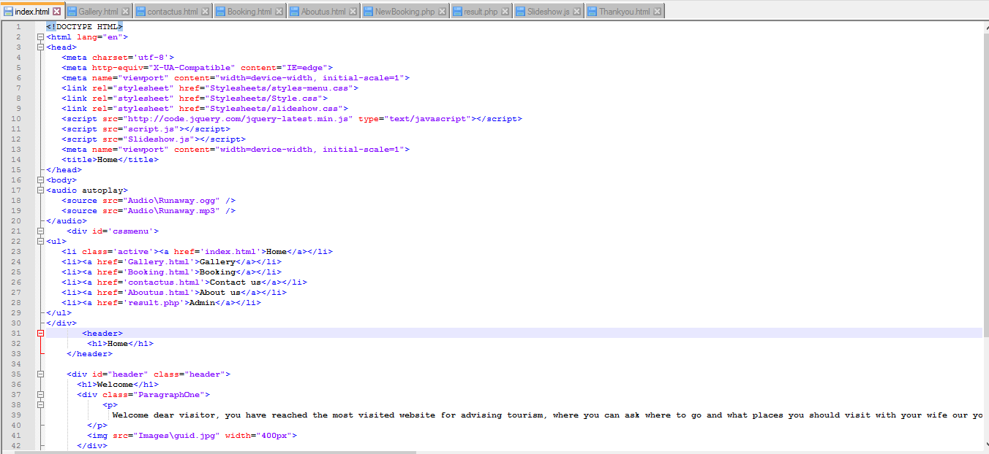 **Coding**

